Computer Science in Middle Schools:
A Guide for Success

The Counselor’s Central Role in Computer Science Education

Introduction
The purpose of this document is to serve as a comprehensive guide for school counselors, administrators, and educators dedicated to the successful development and implementation of a robust Computer Science (CS) course at the middle school level. A successful program requires intentional planning and strategic support, and the school counselor is an essential leader in this initiative. The counselor's role is multi-faceted, focusing on strategic logistical planning, comprehensive student outreach, and continuous program evaluation. This includes:
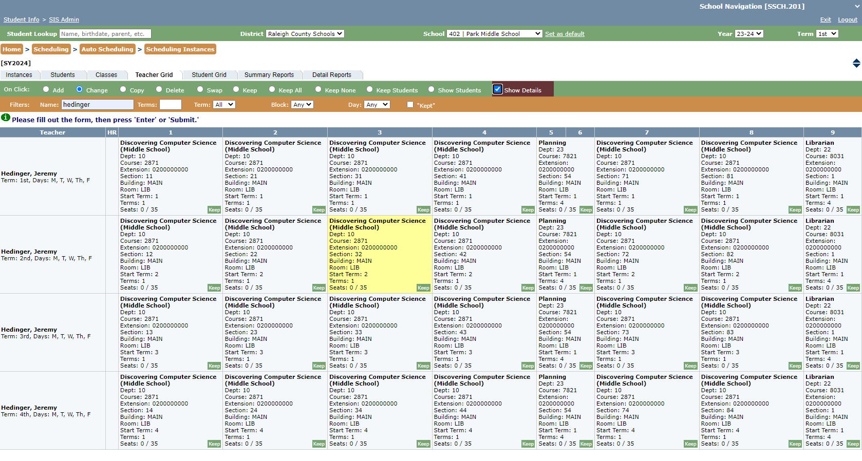
- Master Schedule Integration: Strategically placing the course within the school’s master schedule to maximize student access.
- Availability Optimization: Developing a flexible and adaptive course schedule to increase enrollment and reach diverse student populations.
- Course Promotion: Actively marketing and promoting participation in the CS course to all student demographics.
- Program Evaluation: Assessing the effectiveness of course offerings and making data-driven adjustments to the curriculum and delivery.

-----Phase I: Before Implementation
The foundational step in creating a new Computer Science course involves a thorough internal audit of existing resources and capacity. This preparatory phase ensures the program is built on a sustainable model tailored to the school's unique environment.
- Resource Identification and Staffing: The initial step is to identify dedicated staff and determine the essential building resources available for the program. This assessment must consider the overall student population size to ensure appropriate scaling and resource allocation. A critical component is the selection of a teacher who will champion the course. This individual will be required to complete the necessary, rigorous training programs provided by organizations like Code.org to ensure pedagogical quality and fidelity to the curriculum.
- Course Model Determination: Once staffing and resources are confirmed, a decision must be made regarding the course delivery model. Options to be explored include:
  - Integrated Model: Embedding CS concepts into an existing course (e.g., math or science) for broader exposure.
  - Stand-Alone Course: Offering the course as an independent elective, which often allows for deeper content coverage.
  - Scheduling Structure: Determining the optimal time frame, such as a focused nine-week rotation or a more in-depth semester-long commitment, to best meet student needs and resource constraints. The content offers flexibility, allowing for adaptation to align with student readiness and available school resources.

-----Phase II: During Implementation
Once the course is launched, the counselor shifts focus to enhancing student engagement and awareness, particularly regarding the potential for future careers in the field of Computer Science.
- Career Exposure and Awareness: To effectively bridge the gap between classroom learning and real-world application, counselors can facilitate a virtual Career Fair. This event provides students with direct exposure to CS professionals who can share their personal career trajectories, job responsibilities, and the importance of computer science skills in the modern workforce. This personal connection is invaluable for demystifying the field.
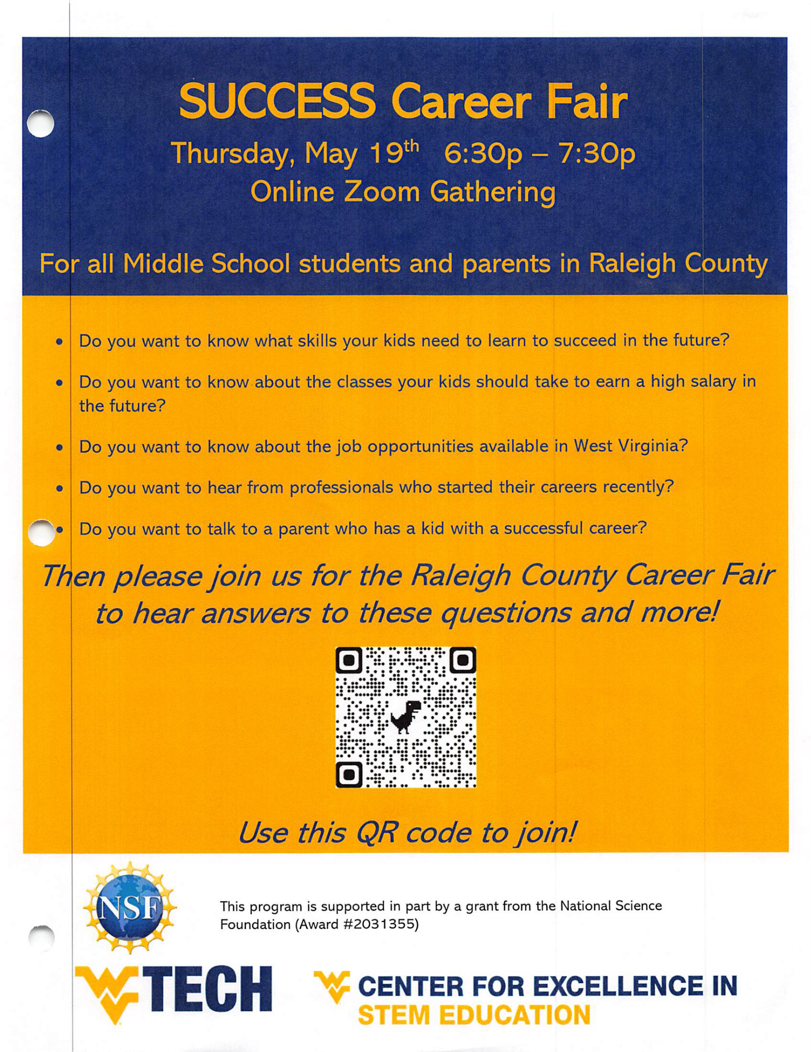
- Assessment and Interest Gauging: The use of pre- and post-surveys is a key strategy for measuring the program's impact. These assessments effectively gauge students' initial interest, existing knowledge, and subsequent understanding of CS concepts and careers. The data collected from these instruments is a vital resource for both teachers and counselors, informing targeted outreach and promotional efforts to sustain enrollment and enthusiasm for the CS course and the broader field.
Pretest: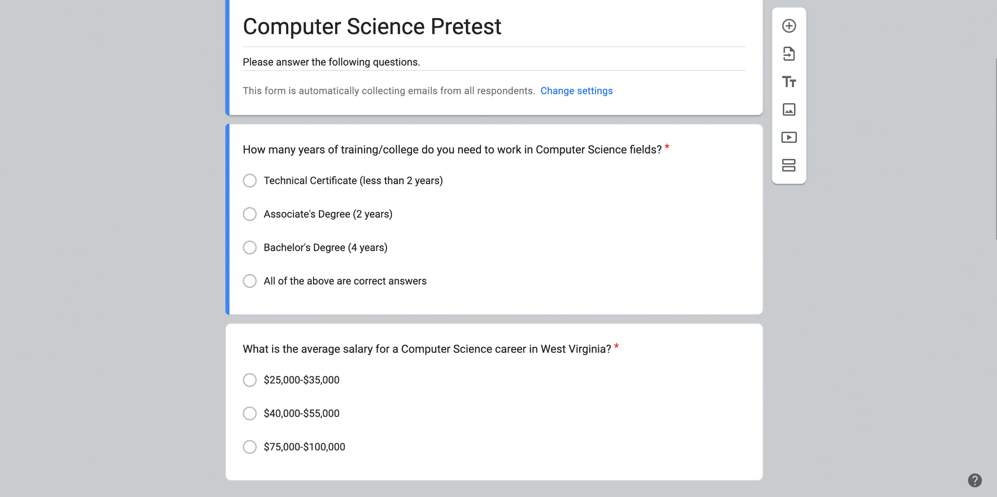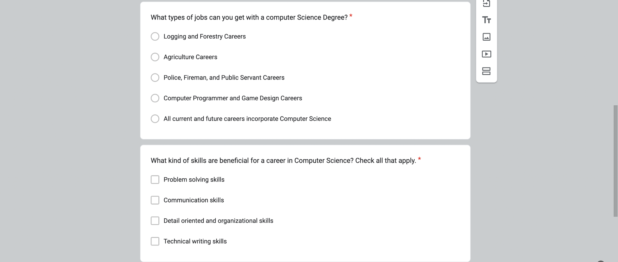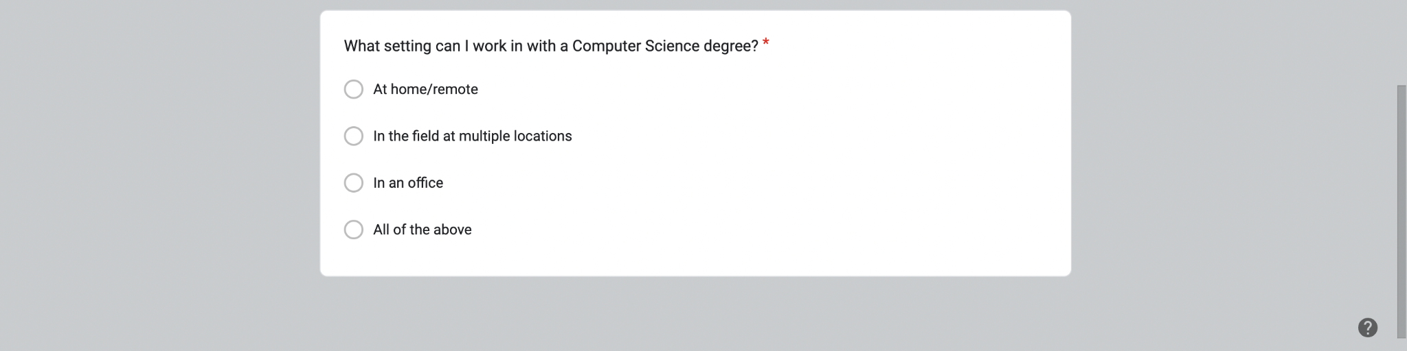

- Supplemental Promotional Activities: To ensure a wide net of student interest, supplemental activities can be strategically implemented within homerooms or academic links. These activities include:
  - Career Interest Inventories: Tools designed to help students discover how their skills and interests align with various CS career pathways.
  - Career and Technical Education (CTE) Lessons: Focused mini-lessons that highlight the practical, hands-on applications of computer science, especially during dedicated periods such as Career and Technical Education Month, to further promote the professional value of the course.
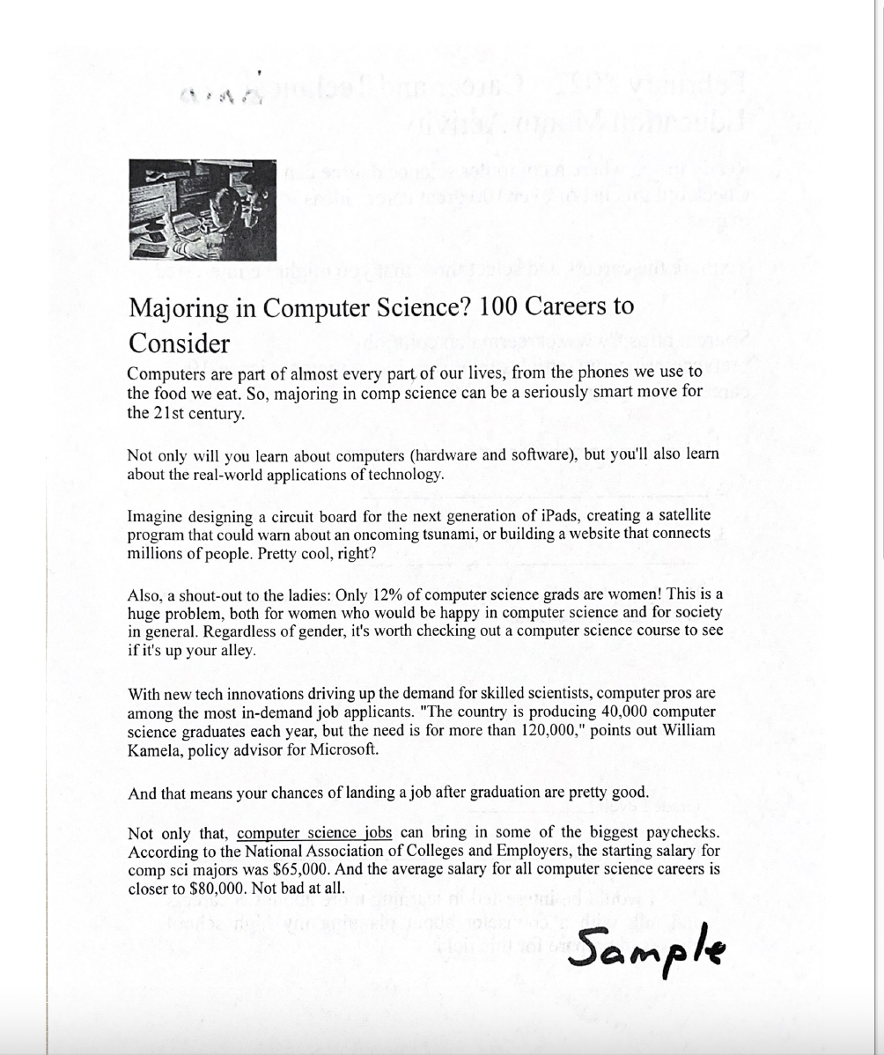
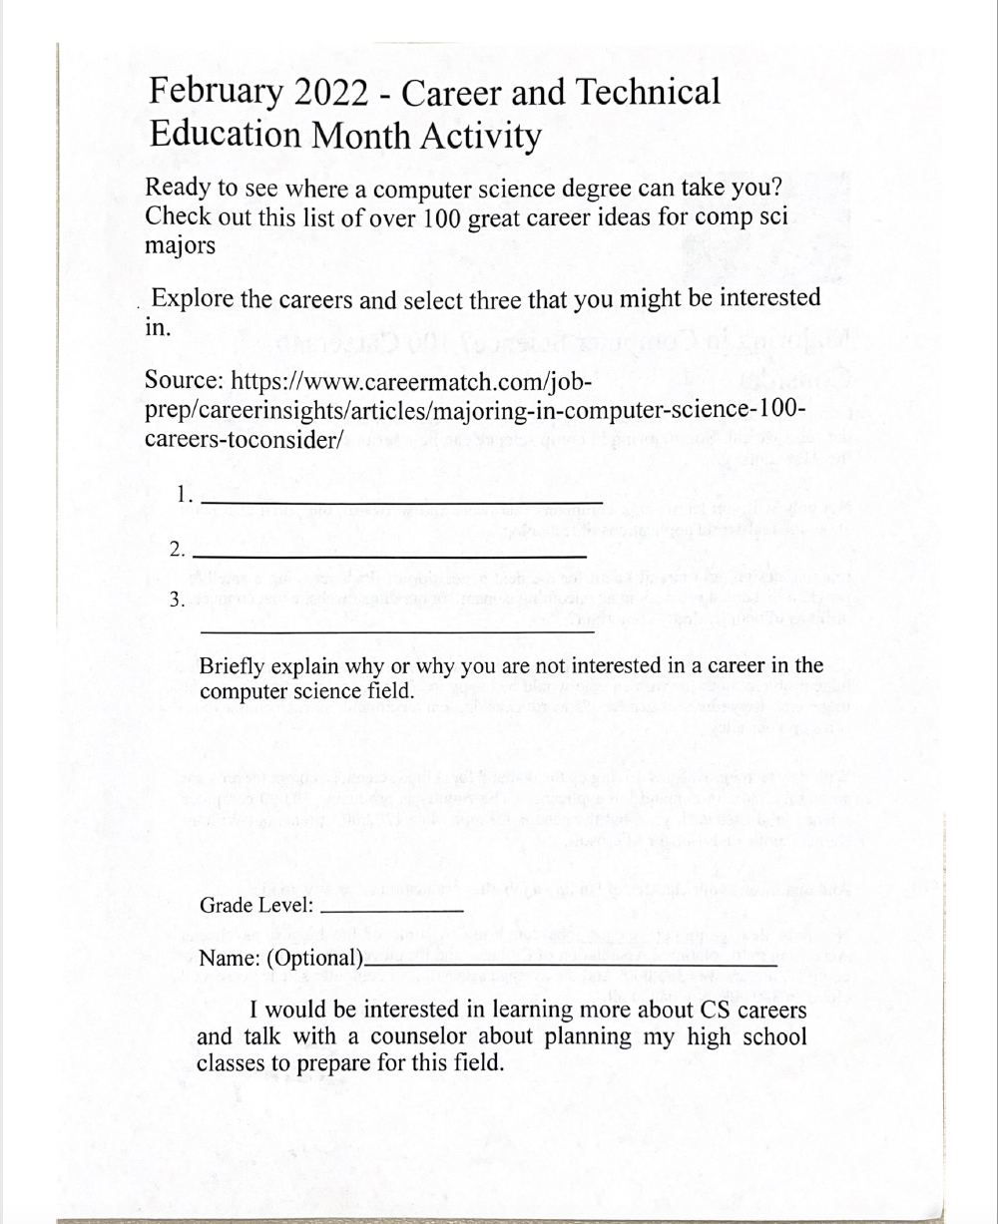

-----Phase III: After Program Review
The final phase involves a critical review and collaborative refinement of the program to ensure continuous improvement and long-term viability.
- Collaborative Program Revision: Regular, structured collaboration among teachers, counselors, and school administration is essential for reviewing program data, identifying areas for curriculum revisions, and making necessary schedule adjustments. This collective effort ensures the course remains relevant, effective, and fully supported.
- Faculty Development: Should any faculty changes occur, the newly identified teacher must be promptly enrolled and complete the mandated training, such as the programs offered through Code.org. Ensuring a consistent level of quality instruction is a non-negotiable step for the sustained success of the Computer Science program.

